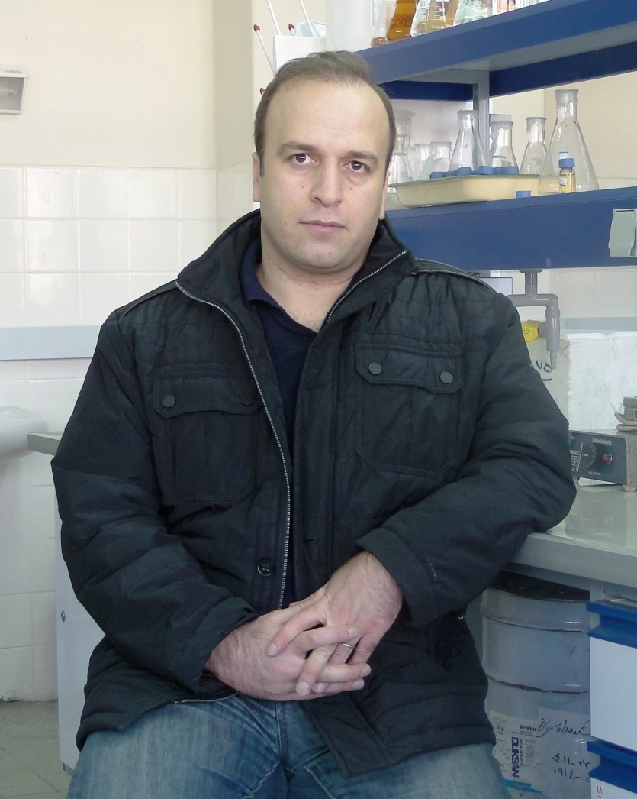 | Javad Ghasemiyan  Pharmacognosy

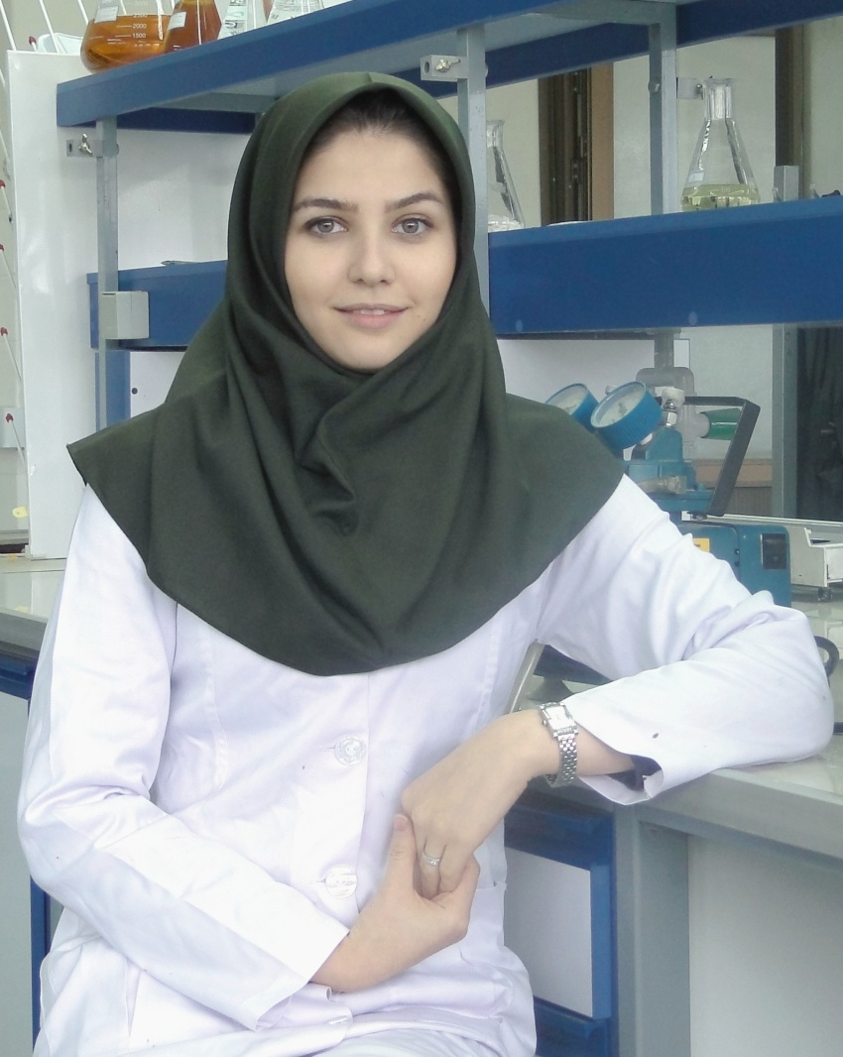 | Parina Asgharian  Pharmacognosy

